Java SE Project

Training And Placement Application

***ParticipantOptionsFrame Documentation***

1. **ParticipantOptionsFrame -**

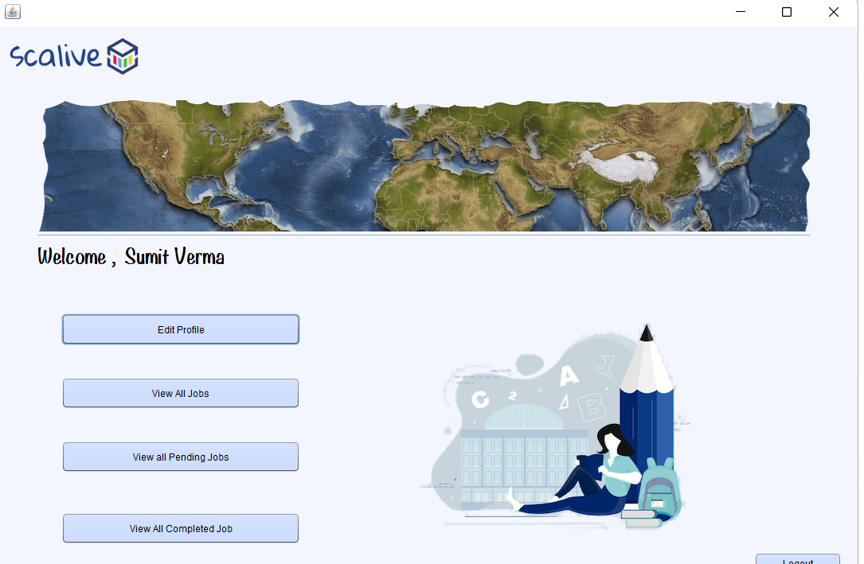

**2. STEPS TO BE DONE IN** **ParticipantOptionsFrame**

In the **ParticipantOptionsFrame** we need to do following steps:

1. Show UserName
2. Allow the user to go back to **login page**
3. Show 4 options **Edit Profile** ,**View All Jobs**, **View All Applied Jobs**, **View All Completed Jobs**

**The Code For Frame**

**public class ParticipantsOptionFrame extends javax.swing.JFrame {**

**public ParticipantsOptionFrame() {**

**initComponents();**

**this.setLocationRelativeTo(null);**

**lblName.setText(CurrentUser.getName());**

**}**

**private void btnAvailableActionPerformed(java.awt.event.ActionEvent evt) {**

**new PtViewAllAvailableJobsFrame().setVisible(true);**

**this.dispose();**

**}**

**private void btnCompletedActionPerformed(java.awt.event.ActionEvent evt) {**

**new PtAllCompletedJobFrame().setVisible(true);**

**this.dispose();**

**}**

**private void btnAppliedActionPerformed(java.awt.event.ActionEvent evt) {**

**new PtAllAppliedJobsFrame().setVisible(true);**

**this.dispose();**

**}**

**private void editProfileActionPerformed(java.awt.event.ActionEvent evt) {**

**new PtEditProfileFrame().setVisible(true);**

**this.dispose();**

**}**

**private void logOutBtnActionPerformed(java.awt.event.ActionEvent evt) {**

**new LoginFrame().setVisible(true);**

**this.dispose();**

**}**